A Seminar report
on

RISC-V PROCESSOR: ARCHITECTURE AND ITS APPLICATION

Submitted by

Suryansh Shukla
To
Department of Electronics and Communication Engineering


Department of
Electronics and Communication Engineering
Madan Mohan Malaviya University of Technology, Gorakhpur (U.P.)
INDIA
February-March, 2026

CANDIDATE DECLARATION

I declare that the written work and ideas are in my own words while other ideas or words included have been adequately cited and reference the original sources. I also declare that I have adhered to all principle of academic honesty and integrity and have not misrepresented or fabricated or falsified any idea/data/fact/source in our submission. I understand that any violation of the above will be cause for disciplinary action by the University and can also evoke penal action from the sources which have thus not been properly cited or from whom proper permission has not been taken when needed.

Suryansh Shukla

Department of Electronics & Communication Engineering

Date: ________

APPROVAL SHEET

The Seminar report titled RISC V processor: Architecture and its Application by Suryansh Shukla is approved for the degree of Bachelor of Technology in Electronics and Communication Engineering.

Coordinators:

Dr. AAAAAAA
Assistant Professor
Department of Electronics and Communication Engineering

_____________________

Dr. BBBBBBB
Assistant Professor
Department of Electronics and Communication Engineering

_____________________

Date: _________
Place: M.M.M.U.T, Gorakhpur

LIST OF FIGURES

S. No. | Figure Description | Page No.
Fig. 1.1 | The Organisation of a computer, showing the five classic component | 1
Fig. 1.2 | CISC VS RISC | 2
Table 2.1 | Classical RISC Architecture Papers | 3
Table 2.2 | RISC-V Research & Development Papers | 4
Fig. 2.1 | Yunsup Lee holding RISC V prototype chip. At UC  Berkeley Par Lab Winter Retreat, January 2013 | 4
Fig. 2.2 | Framework Laptop 13 containing DC-ROMA RISC-V AI PC motherboard running Ubuntu 24.04, showing neofetch output | 5
Fig. 3.1 | RISC-V ISA | 6
Fig. 3.2 | RISC-V Base Instruction format | 8
Fig. 3.3 | Load Instruction, Single Cycle Datapath | 10
Fig. 4.1 | Application of RISC V ISA Over Time | 13

ABSTRACT

Microprocessors can be designed using two types of instruction sets: CISC (Complex Instruction Set Computer) and RISC (Reduced Instruction Set Computer). The real advantage of a RISC processor is the use of small-size instructions to execute a step of a program. This leads to a larger program size compared to the complex instructions used in CISC processor architecture. However, the instruction decoder area inside the processor, as well as the number of machine cycles per instruction, are fewer than in CISC.
What makes the RISC-V processor highly advantageous in the current market is its open-source license. Its architecture can be independently used by any company to develop its own processor, unlike CISC or ARM processors, which require licensing for use.
In addition to its simple instruction set, RISC architecture follows a load–store design in which memory operations are performed only through load and store instructions, while all other instructions are executed using registers. This reduces memory access time and improves overall processing speed. RISC processors also support efficient pipelining due to their fixed-length instruction format, which increases instruction throughput.
Furthermore, RISC-V provides a modular architecture with customizable extensions, allowing designers to develop processors suitable for embedded systems, IoT devices, and high-performance computing applications.

TABLE OF CONTENTS

CANDIDATE’S DECLARATION i
APPROVAL SHEET iii
LIST OF FIGURES v
ABSTRACT vi

CHAPTER 1: INTRODUCTION.........................................................................................1
1.1 Introduction to Microprocessors………………………………………………………………1
1.2 Evolution of Instruction Set Architecture……………………………………………………..1
1.3 CISC vs RISC Architecture…….…………………………………………………….…...……2
1.4 Need for Open Instruction Set…………………………………………………………...……..2
1.5 Introduction to RISC Architecture…………………………………………………………….2
1.6 Motivation……………….……………………………………………………….…...................2
1.7 Objectives……………………………………………………..…………………………………3
1.8 Organisation of the Report……………………………………………………….…………….3

CHAPTER 2: LITERATURE REVIEW ...........................................................................4
2.1 History of RISC Architecture…….……………………………………………………………4
2.2 Comparison with ARM and x86……………………………………………………………....5
2.3 Research Developments in RISC-V……...……………………………………………………5
2.4 Industrial Adoption Trends………………………………………………………..…………..6
2.5 Limitations of Existing Architecture……………….………………………………………....6

CHAPTER 3: METHODOLOGY AND TECHNICAL DETAILS ……………………7

3.1: RISC-V ARCHITECTURE…………………………………………………..………..……...7
3.1.1 Design Philosophy......................................................................................................................7
3.1.2 Base ISA (RV321, RV64I). .........................................................................................................8
3.1.3 Register Organization…………………………………………………………………………8
3.1.4 Instruction Formats……………………………………………………………………………8
3.1.5 Load-Store Architecture………………………………………………………………………9
3.1.6 Pipeline Architecture…………………………………………………………………………..9
3.1.7 Memory Organization…………………………………………………………………………9
3.1.8 Datapath……………….……………………………………………………………………..10

3.2: RISC-V EXTENSIONS…………………………………………………12
3.2.1 Standard Extensions (M, A, F, D, C)………………………………………………………...12
3.2.2 Privilege Architecture………………………………………………………………………..12
3.2.3 Exception and Interrupt Handling………………………………………………………….13
3.2.4 Custom Extensions …………………………………………………………………… .. .…13
CHAPTER 4: APPLICATIONS…..…………………………………………………........14
4.1 Embedded Systems……………………………………………………………………………. .14
4.2 IoT Devices………………………………………………………………………………………14
4.3 AI and High-Performance Computing………………………………………………………...15
4.4 Real Industry Processors……………………………………………………………………….15
CHAPTER 5: ADVANTAGES AND CHALLENGES….. ……………..........................16
CHAPTER 6: CONCLUSION AND FUTURE SCOPE ..………………….….….........17
REFERENCES………………………..……………………….……………………...……18

CHAPTER 1
INTRODUCTION

1.1 Introduction to Microprocessors
A microprocessor is a programmable electronic device that performs arithmetic, logical, and control operations based on instructions stored in memory. It acts as the CPU of a system, and integrating the CPU onto a single chip significantly reduced size, cost, and power consumption.
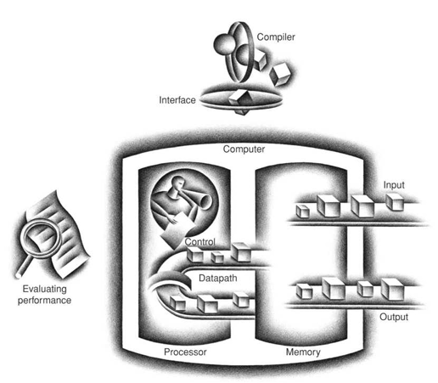
It operates using the fetch–decode–execute cycle, where instructions are fetched, decoded, and executed through components such as the ALU and registers.
The main components include the Arithmetic Logic Unit (ALU), Control Unit (CU), registers, and Program Counter (PC). Cache memory is also used in modern processors to increase speed. Microprocessors are designed based on an Instruction Set Architecture (ISA) such as x86, ARM, and RISC-V, which defines instructions, data formats, and execution behaviour.
Figure 1.1 The organization of a computer, showing the five classic components.
Source: Computer Organisation and Design, David A. Patterson, John L. Hennessy

1.2 Evolution of Instruction Set Architecture
ISA defines the interface between hardware and software. Early processors had limited instruction sets due to hardware constraints.
During the 1970s and 1980s, CISC architectures like Intel 8086 introduced complex instructions to reduce program size. Later research showed that simpler instructions improve performance through pipelining, leading to the development of RISC architecture with fixed-length, simple instructions executed in fewer cycles.
Projects like IBM 801 and Berkeley RISC demonstrated higher efficiency. Modern processors combine both approaches, but RISC principles dominate embedded and energy-efficient systems. The need for flexibility and lower licensing costs led to open architectures such as RISC-V.

1.3 CISC vs RISC Architecture
CISC uses complex, variable-length instructions capable of multiple operations in one instruction, reducing instruction count but increasing hardware complexity.
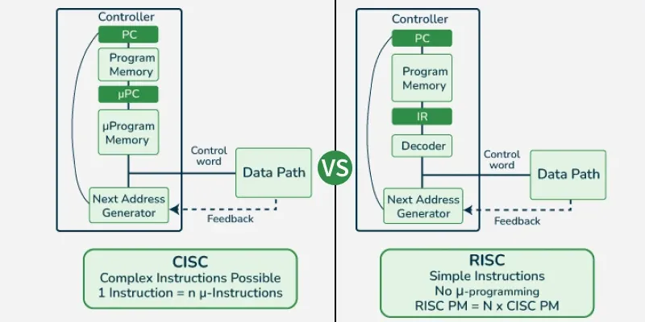
Figure 1.2 CISC VS RISC
Source:https://media.geeksforgeeks.org/wp-content/uploads/20250911173826277021/vs.webp
RISC uses simple, fixed-length instructions and follows a load–store model. Each instruction performs a single task, enabling efficient pipelining and simpler hardware design. Examples include ARM and RISC-V. RISC is widely used in scalable and low-power systems.

1.4 Need for Open Instruction Set
Most ISAs like x86 and ARM are proprietary and require licensing fees, limiting customization and increasing costs.
An open ISA allows free implementation without royalties, encouraging innovation and research. RISC-V is a leading example of an open, modular ISA.

1.5 Motivation
The motivation for studying RISC-V comes from the growing need for flexible, cost-effective, and energy-efficient processors. Unlike proprietary architectures, RISC-V provides an open and extensible design that supports customization for applications such as AI, IoT, and embedded systems.
Its modular structure allows designers to include only necessary features, improving efficiency. Its simplicity also makes it suitable for academic learning and research.
This structure ensures a logical flow from fundamental concepts to advanced architectural features and applications.
.
1.6 Objectives
The specific objectives of this study are:
- To understand the fundamentals of Instruction Set Architecture (ISA) and its role in microprocessor design.
- To compare CISC and RISC architectures in terms of structure and performance.
- To study the design philosophy of RISC-V (simplicity, modularity, scalability).
- To analyse the base instruction sets (RV32I and RV64I), including registers, instruction formats, and load–store architecture.
- To examine major RISC-V extensions (multiplication, atomic, floating-point, compressed).
- To explore real-world applications in embedded systems, IoT, AI, and high-performance computing.

1.7 Organization of the Report
- Chapter 1: Introduction to Microprocessors and ISA, evolution of ISA, and CISC vs RISC comparison.
- Chapter 2: Literature review, RISC history, comparison with ARM and x86, and industrial trends.
- Chapter 3: Methodology and Technicals details base instruction sets, registers, pipeline, and memory organization, extensions, Datapth.
- Chapter 4: Real-world applications in embedded systems, IoT, AI, and HPC.
- Chapter 5: Advantages and challenges of RISC-V adoption.
- Chapter 6: Conclusion and future scope in the semiconductor industry

CHAPTER 2
LITERATURE REVIEW

2.1 History of RISC Architecture
Reduced Instruction Set Computer (RISC) architecture emerged in the late 1970s as a response to the growing complexity of CISC processors. Researchers observed that many complex instructions were rarely used and that simpler instructions could achieve better performance through efficient pipelining.
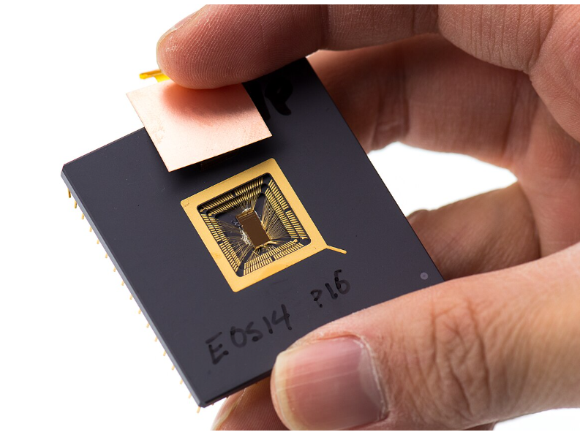
The IBM 801 project demonstrated that fixed-length, simple instructions could outperform complex designs. Later, the Berkeley RISC and Stanford MIPS projects introduced the load–store architecture and pipeline optimization techniques. These developments proved that simplified instruction sets improved speed, efficiency, and hardware design.
RISC principles later influenced commercial processors such as SPARC, MIPS, and ARM. The evolution of this philosophy ultimately led to the development of RISC-V, which extends RISC concepts with modularity and openness.
Figure 2.1: Yunsup Lee holding RISC V prototype chip. At UC Berkeley Par Lab Winter Retreat, January 2013.
Source: https://www.flickr.com/photos/dcoetzee/8694597164/
S. No. | Paper Title | Authors | Year | Institution / Journal | Key Contribution
1 | The Case for the Reduced Instruction Set Computer | David A. Patterson, David R. Ditzel | 1980 | ACM SIGARCH | Introduced RISC concept; argued simpler instructions improve performance via pipelining.
2 | RISC I: A Reduced Instruction Set VLSI Computer | David A. Patterson et al. | 1981 | UC Berkeley | Demonstrated load–store architecture and fixed-length instruction benefits.
3 | MIPS: A Microprocessor Architecture | John L. Hennessy | 1982 | Stanford University | Introduced pipeline optimization and compiler-based scheduling.
Table 2.1: Classical RISC Architecture Papers

2.2 Comparison with ARM and x86
x86 and ARM are dominant processor architectures today. x86 follows a CISC design with variable-length instructions and high architectural complexity, mainly used in PCs and servers. ARM follows RISC principles and focuses on power efficiency, making it dominant in mobile and embedded systems.
However, both ARM and x86 are proprietary and require licensing agreements. In contrast, RISC-V is open and royalty-free, allowing organizations to implement and customize the ISA without restrictions. Its modular extension model provides greater flexibility and scalability.

2.3 Research Developments in RISC-V
RISC-V has attracted significant research interest due to its open design. Researchers are developing custom instruction extensions for AI, cryptography, and signal processing.
S. No. | Paper Title | Authors | Year | Institution / Journal | Key Contribution
1 | The RISC-V Instruction Set Manual, Volume I: User-Level ISA | Andrew Waterman, Krste Asanović et al. | 2011 | UC Berkeley | Introduced open, modular, royalty-free ISA architecture.
2 | A Survey of RISC-V Architecture and Its Applications | Yunsup Lee et al. | 2019 | IEEE Access | Analyzed industrial adoption, AI extensions, IoT applications, scalability.
Table 2.2: RISC-V Research & Development Papers

Efforts are also focused on low-power embedded systems, security enhancements, and high-performance computing using vector extensions
Because of its simplicity and transparency, RISC-V is widely adopted in academic institutions for processor design research and education.

2.4 Industrial Adoption Trends
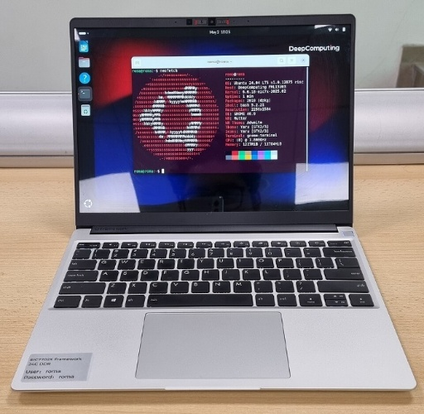
RISC-V adoption has increased rapidly due to cost efficiency and flexibility. Companies can design processors without paying licensing fees.
Figure 2.2: Framework Laptop 13 containing DC-ROMA RISC-V AI PC motherboard running Ubuntu 24.04, showing neofetch output
Source: https://upload.wikimedia.org/wikipedia/commons/thumb/8/84/DC_ROMA_AI_PC_Framework_Laptop_13_Ubuntu.jpg/960px-DC_ROMA_AI_PC_Framework_Laptop_13_Ubuntu.jpg

It is widely used in embedded systems, IoT devices, AI accelerators, automotive electronics, and storage controllers. Support from major technology companies and government initiatives has strengthened its ecosystem. Although still developing compared to ARM and x86, RISC-V is becoming a commercially viable architecture.

2.5 Limitations of Existing Architectures
ARM and x86 face limitations related to licensing costs, architectural complexity, and restricted customization. x86 has become highly complex due to backward compatibility, while ARM limits deep ISA-level modifications.
Proprietary control also restricts innovation and creates long-term dependency risks.
These challenges highlight the importance of open architectures. RISC-V addresses these issues by providing a flexible, extensible, and royalty-free instruction set suitable for modern computing needs.

CHAPTER 3
METHODOLOGY AND TECHNICAL DETAILS

3.1 RISC-V ARCHITECTURE
3.1.1 Design Philosophy
RISC-V is designed based on simplicity, modularity, scalability, and openness. Unlike traditional ISAs that evolved with increasing complexity, RISC-V was created with a clean and structured approach.
The base ISA contains only essential instructions with fixed 32-bit formats, simplifying decoding and improving pipeline efficiency. It follows a base-plus-extension model, where RV32I or RV64I provides integer operations, and optional extensions (M, A, F, D, C) add advanced features.
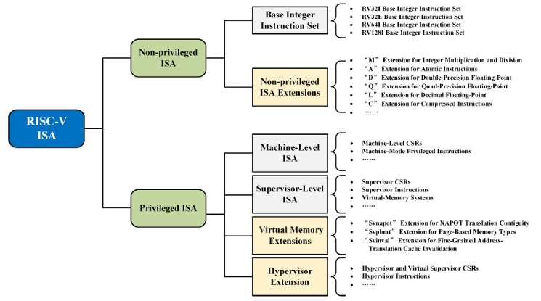
Figure 3.1: RISC V ISA
Source RISC-V Instruction Set Architecture Extensions: A Survey ENFANG CUI , (Member, IEEE), TIANZHENG LI, AND QIAN WEI)
RISC-V supports multiple word sizes (32-bit, 64-bit, and 128-bit under development), enabling use from embedded systems to high-performance computing. Its open-standard nature allows free implementation and custom extensions. The architecture follows a load–store model, where only load/store instructions access memory, and all operations occur on registers. It avoids condition codes and implicit side effects, reducing hardware and compiler complexity.
3.1.2 Base ISA (RV32I, RV64I)
The base ISA defines the minimum instruction set for a functional processor.
- RV32I: 32-bit registers, suited for embedded and low-power systems.
- RV64I: 64-bit registers, used in servers and high-performance systems.
Both include:
- Arithmetic and logical instructions (ADD, SUB, AND, OR)
- Immediate operations (ADDI, ANDI)
- Load/store instructions (LW, SW, LD, SD)
- Branch and jump instructions (BEQ, JAL)
- System instructions (ECALL, EBREAK)
RISC-V provides 32 general-purpose registers (x0–x31), with x0 hardwired to zero. All instructions are fixed 32 bits and follow load–store architecture. Advanced features are added through extensions.

3.1.3 Register Organization
RISC-V includes 32 integer registers (x0–x31).
- RV32I uses 32-bit registers
- RV64I uses 64-bit registers
Register x0 always returns zero. Registers are categorized as temporary (t), saved (s), argument (a), stack pointer (sp), return address (ra), etc., following calling conventions.
Optional floating-point extensions add 32 floating-point registers (f0–f31).
RISC-V does not use condition code registers; comparison results are stored in general registers. This simplifies pipelining and control logic.

3.1.4 Instruction Formats
RISC-V uses fixed 32-bit instruction formats for simplicity. The six main types are:
- R-type: Register operations (ADD, SUB)
- I-type: Immediate, load, system instructions (ADDI, LW)
- S-type: Store instructions (SW)
- B-type: Branch instructions (BEQ)
- U-type: Upper immediate (LUI, AUIPC)
- J-type: Jump instructions (JAL)

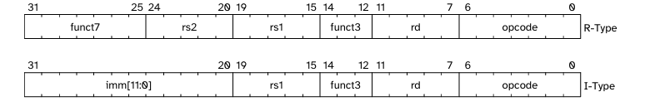
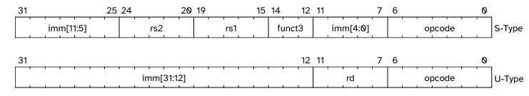
Figure 3.2: RISC V Base Instruction format
Source: The RISC-V Instruction Set Manual Volume I | © RISC-V International
Uniform placement of rs1, rs2, and rd simplifies decoding and improves pipeline efficiency.

3.1.5 Load–Store Architecture
RISC-V follows a pure load–store architecture. Memory is accessed only through load/store instructions, while arithmetic operations occur in registers.
Effective Address = Base Register + Immediate Offset
Advantages:
- Simplified hardware
- Efficient pipelining
- Reduced instruction complexity
- Better compiler optimization
Compared to CISC, RISC-V uses more instructions but achieves simpler and scalable hardware design.

3.1.6 Pipeline Architecture
RISC-V supports efficient pipelining due to fixed-length instructions and simple formats. A typical 5-stage pipeline includes:
- IF – Instruction Fetch
- ID – Instruction Decode
- EX – Execute
- MEM – Memory Access
- WB – Write Back
Pipeline hazards include data, control, and structural hazards, handled using forwarding, stalls, and branch prediction

3.1.7 Memory Organization
RISC-V uses byte-addressable memory.
- RV32I supports up to 4 GB
- RV64I supports larger memory spaces
Supports byte, half-word, word, and double-word accesses (LB, LH, LW, LD). Proper alignment improves performance.
The PC increments by 4 (or 2 for compressed instructions). RISC-V supports memory ordering using FENCE instructions and virtual memory in privileged systems.

3.1.8 Datapath
The datapath is the set of hardware components in a processor that execute instructions and transfer data between units. It forms the core of the CPU and works with the control unit to perform the fetch–decode–execute cycle in a RISC-V processor.
Working Principle
- Instruction Fetch: The PC sends the address to instruction memory to fetch the instruction.
- Instruction Decode: The instruction is decoded and source registers are read.
- Execute: The ALU performs arithmetic/logic operations or computes memory addresses.
- Memory Access: Data memory is accessed for load/store instructions.
- Write Back: The result is written to the destination register.
In a single-cycle processor, all stages complete in one clock cycle
Example:
Address | Instruction | Type
0x1000 | L7: lw x6, -4(x9) | I

-4 | x9 | 010 | x6 | 0000011
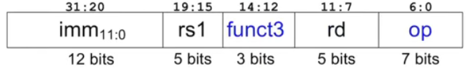

Process:
Step 1: Fetch Instruction
Program counter is connected to Instruction memory, where the program counter have address 0x1000 which is then used by the instruction memory to fetch the instruction at 0x1000 i.e. 0xFFC4A303.
Step 2: Read Source operand (rs1) from Register file – Instruction Decode
Instruction memory then moved to register file for the source register to access the data stored in x9 (reg 9), which gets the data as 0x2004.
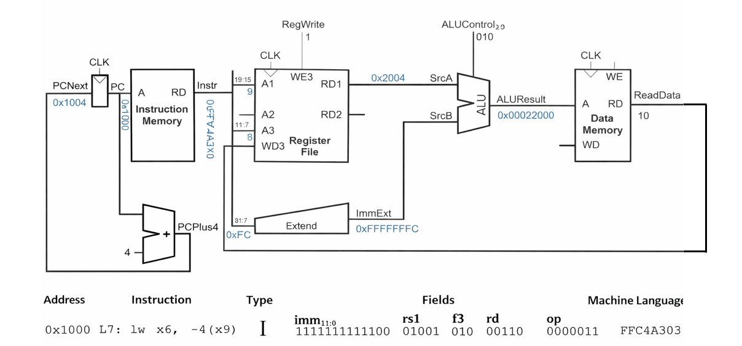
Figure 3.3: Load Instruction, Single Cycle Datapath
Source: A. Waterman, Y. Lee, D. A. Patterson, and K. Asanović, “The RISC-V Instruction Set Manual, Volume I: Unprivileged ISA,”
Step 3: Extend Immediate value
The hexadecimal value for -4 is 0xFFC which is then extended to 32 bit number 0xFFFFFFFC.
Step 4: Compute the memory address -- Execute
Using ALU - ADD to compute the value from source A i.e. from x9 (0x2004) and the immediate value as source B from Extend. The ALU result is 0x00002000.
Step 5: Read data from memory and write it back to register file
– Memory access and write back
The ALU result is the data address which is used in data memory for reading data. Afterward data can be written to the x6 register in register file.

3.2 RISC-V EXTENSIONS

3.2.1 Standard Extensions (M, A, F, D, C)
RISC-V follows a modular ISA design. The base ISA (RV32I/RV64I) supports only integer operations, while advanced features are added through optional extensions, allowing optimization of performance, area, and power.
M Extension
Adds integer multiplication and division (MUL, DIV, REM). Used in computation and signal processing.
A Extension
Provides atomic operations (AMO, LR/SC) for synchronization in multi-core systems.
F Extension
Supports 32-bit floating-point operations (IEEE 754) with 32 floating-point registers. Used in scientific and DSP applications.
D Extension
Adds 64-bit floating-point operations for higher numerical accuracy in HPC systems.
C Extension
Introduces 16-bit compressed instructions to reduce code size, memory usage, and power consumption.
Modular Benefits:
- Implement only required features
- Reduce hardware complexity
- Scalable from IoT to servers
Example:
IoT → RV32I + C
Server → RV64I + M + A + F + D

3.2.2 Privilege Architecture
RISC-V defines three privilege levels for secure execution:
- Machine Mode (M-mode): Highest level; handles booting, interrupts, and hardware control.
- Supervisor Mode (S-mode): Runs the operating system; manages memory and processes.
- User Mode (U-mode): Runs applications with restricted access.
Transitions occur via ECALL, interrupts, or exceptions.
Control and Status Registers (CSRs)
Special registers manage interrupt status, exception causes, and system configuration.
Privilege separation ensures security, isolation, and OS support.

3.2.3 Exception and Interrupt Handling
Exceptions occur during instruction execution (e.g., illegal instruction, divide by zero).
Interrupts come from external devices (timers, I/O).
Both are handled using the trap mechanism:
- Save PC
- Record cause in CSR
- Execute trap handler
- Resume execution
Important CSRs: mepc, mcause, mtval, mstatus
This mechanism ensures reliability and multitasking support.

3.2.4 Custom Extensions
RISC-V allows designers to add custom instructions using reserved opcode space.
Applications include AI/ML, cryptography, and DSP.
Advantages:
- Higher performance
- Better energy efficiency
- Reduced code size
- Application-specific optimization
Custom extensions make RISC-V flexible, scalable, and innovation-friendly.

CHAPTER 4
APPLICATIONS
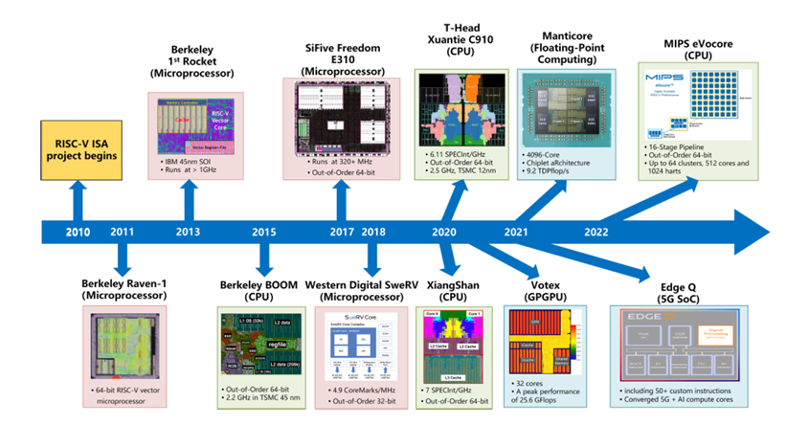
Figure 4.1: Application of RISC V ISA Over Time
Source: RISC-V Instruction Set Architecture Extensions: A Survey ENFANG CUI , (Member, IEEE), TIANZHENG LI, AND QIAN WE)
4.1 Embedded Systems
Embedded systems are specialized computing systems used in consumer electronics, automotive control, industrial automation, and medical devices. RISC-V is well suited for embedded applications due to its simple base ISA (RV32I), modular design, and low power consumption.
By implementing only required extensions such as M (multiplication), C (compressed instructions), and A (atomic operations), designers can reduce hardware complexity and cost. A configuration like RV32I + C is often sufficient for small microcontrollers.
The load–store architecture and simple decoding reduce power consumption, making RISC-V ideal for battery-operated and real-time systems. Its open nature also allows custom embedded processor design without licensing fees. Applications include smart home devices, industrial controllers, automotive sensors, wearables, and monitoring systems.

4.2 IoT Devices
IoT devices require compact, low-power, and cost-effective processors. RISC-V’s lightweight architecture and modular extensions make it highly suitable.
Using RV32I with optional C extension, designers can minimize memory usage and energy consumption. The architecture supports secure boot and custom security features, which are important for connected devices.
RISC-V microcontrollers in IoT systems handle sensor data, wireless communication, edge processing, and power management. Its scalability also supports edge computing, reducing latency and bandwidth usage. Applications include smart agriculture, energy meters, environmental monitoring, wearables, and home automation.

4.3 AI and High-Performance Computing
AI and HPC require high computational capability and parallel processing. RISC-V supports custom and vector extensions that accelerate matrix multiplication, convolution, and data processing tasks.
The RV64I architecture, combined with floating-point extensions (F and D), enables large memory addressing and high-precision computation. RISC-V is also used in heterogeneous systems, where general-purpose cores manage control tasks while accelerators perform intensive processing.
Applications include neural network inference, image processing, scientific simulations, big data analytics, and edge AI.

4.4 Real Industry Processors
RISC-V has moved beyond research into commercial adoption. Companies such as SiFive design customizable RISC-V cores for embedded and application processors. Western Digital uses RISC-V in storage controllers and plans large-scale deployment.
Organizations like Alibaba (T-Head) have developed high-performance RISC-V processors for IoT and computing systems. Major companies including NVIDIA, Qualcomm, and Samsung integrate RISC-V cores within SoCs for control and accelerator management.
Key advantages driving adoption include:
- Reduced licensing costs
- High customization capability
- Scalability across applications
- Expanding software ecosystem
Although ARM and x86 still dominate mainstream markets, RISC-V is rapidly expanding in embedded, IoT, and domain-specific computing.
CHAPTER 5
ADVANTAGES AND CHALLENGES

RISC-V has gained rapid global adoption due to its unique advantages, though it also faces certain challenges.
5.1 Advantages
1. Open and Royalty-Free:
RISC-V is an open-standard ISA that does not require licensing fees, reducing development costs and encouraging innovation.
2. Modular Design:
Its base-plus-extension model (M, A, F, D, C) allows designers to implement only required features, optimizing performance, area, and power.
3. Scalability:
Supports RV32, RV64, and future RV128 architectures, making it suitable from embedded systems to high-performance servers.
4. Simplicity and Efficiency:
Fixed-length instructions and load–store architecture simplify hardware design and improve pipeline performance.
5. Custom Extensions:
Supports domain-specific instructions for AI, cryptography, and specialized accelerators without breaking compatibility.
6. Research Friendly:
Widely adopted in academia due to openness and ease of experimentation.

5.2 Challenges
1. Ecosystem Maturity:
Toolchains and commercial support are still developing compared to ARM and x86.
2. Strong Competition:
ARM dominates mobile/embedded markets, while x86 leads in PCs and servers.
3. High-End Performance:
Advanced microarchitecture design is required to compete at high-performance levels.
4. Extension Fragmentation:
Excessive customization may cause compatibility issues if not standardized.
CHAPTER 6
CONCLUSION AND FUTURE SCOPE
6.1 Conclusion
RISC-V represents a major advancement in processor architecture by combining simplicity, modularity, scalability, and openness. Unlike proprietary architectures such as ARM and x86, it provides a royalty-free and customizable instruction set that encourages innovation.
This report discussed microprocessor fundamentals, ISA evolution, and the comparison between CISC and RISC approaches. RISC-V’s design emphasizes fixed-length instructions, load–store architecture, and efficient pipelining. The base ISA (RV32I and RV64I) offers a minimal and scalable foundation, while extensions (M, A, F, D, C) add functionality without unnecessary complexity.
Its adaptability across embedded systems, IoT, AI, and high-performance computing, along with increasing industrial adoption, highlights its growing importance. Although challenges such as ecosystem maturity remain, RISC-V shows strong potential for future processor development.

6.2 Future Scope
RISC-V has a promising future due to its open and extensible architecture. Expected growth areas include:
- Artificial Intelligence: Custom vector and AI extensions for data-intensive applications.
- IoT Systems: Low-power implementations for smart and connected devices.
- Edge Computing: Localized processing to reduce latency and bandwidth usage.
- Automotive Electronics: Flexible solutions for advanced driver-assistance systems.
- Secure Computing: Hardware-level security enhancements.
- Academic Research: Continued innovation through open architectural experimentation.
As the industry shifts toward open and customizable hardware, RISC-V is likely to play a key role in shaping next-generation computing systems.

REFERENCES

[1] A. Waterman, Y. Lee, D. A. Patterson, and K. Asanović,
“The RISC-V Instruction Set Manual, Volume I: Unprivileged ISA,”
Technical Report UCB/EECS-2014-54, EECS Department, University of California, Berkeley, Berkeley, CA, USA, May 2014.
[2] D. A. Patterson and D. R. Ditzel,
“The Case for the Reduced Instruction Set Computer,”
ACM SIGARCH Computer Architecture News, vol. 8, no. 6, pp. 25–33, Oct. 1980.
[3] D. A. Patterson and J. L. Hennessy,
Computer Organization and Design: RISC-V Edition,
1st ed., Morgan Kaufmann, 2017.
[4] D. A. Patterson and J. L. Hennessy,
Computer Architecture: A Quantitative Approach, 6th ed.,
Morgan Kaufmann, 2019.
[5] A. Waterman,
“Design of the RISC-V Instruction Set Architecture,”
Ph.D. dissertation, University of California, Berkeley, 2016.
[6] K. Asanović and D. A. Patterson,
“Instruction Sets Should Be Free: The Case for RISC-V,”
EECS Department, University of California, Berkeley, Technical Report, 2014.
[7] RISC-V International,
The RISC-V Instruction Set Manual, Volume II: Privileged Architecture, Version 1.12, 2021. Available: https://riscv.org/specifications/
[8] SiFive,
“An Introduction to RISC-V Architecture,” White Paper, 2020.
[9] Arm Holdings,
ARM Architecture Reference Manual, ARM Ltd., Cambridge, U.K.
[10] RISC-V Instruction Set Architecture Extensions: A Survey ENFANG CUI , (Member, IEEE), TIANZHENG LI, AND QIAN WEI)

